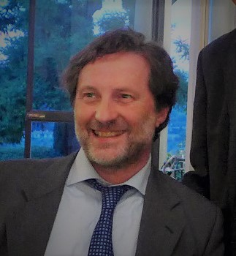

ALBERTO PASSI MD PhD
Full Professor of Biochemistry
Department of Medicine and Surgery (DMC)
School of Medicine - University of Insubria – Varese-ITALY
Via Dunant,5 - 21100 Varese- ITALY. tel. +39+0332+217142 fax. +39+0332+217119
e-mail: alberto.passi@uninsubria.it
Education
1995 Specialization in Clinical Biochemistry cum laude, University of Pavia.
1992 Doctoral Degree Doctoral Degree in Biochemistry, Department of Biochemistry, University of Pavia
and Genoa, Italy.
1987 Degree in Medicine and Surgery cum laude, University of Pavia, Italy.
Experience
Director of Clinical Pathology Laboratory (2018-present) Director Pathology Laboratory of University Hospital.
Research Scholar Cleveland Clinic Foundation (OH– USA) (2000-2001)
Board Certification and Licensure
1988, Italian Medical Association.
Academic Resposabilities
Dean of the Medical School University of Insubria (2021-present)
Component of the Accademia Gerolamo Cardano (Italy)
Component of the Istituto Lombardo Accademia di Scienze e Lettere (Italy).
Journal Editorial board memberships
- Editor Journal of Biological Chemistry (2011-2016)
- Associate Editor Connective Tissue Research
- Associate Editor Molecular Biology Research - ECM
- Associate Editor Molecular Biology Reports
- Academic editor Plos ONE
- Editor Matrix Biology
- Editor Open Biology Journal
- Editor of Frontiers in membrane physiology and biophysics
Research
The Biochemistry Research Group at the University of Insubria is made up of a full professor and three associate professors, supported by a technical officer and Ph.D. students and a post doc, and belongs to the Department of Medicine and Surgery of the Medical School.
The research competence of the Biochemical Unit lies in the metabolism of extracellular matrix components, both in normal models and in models of various human diseases, including degenerative diseases such as atherosclerosis and cancer. The main focus of research is the cellular metabolism of proteoglycans and hyaluronic acid, the most important free polymer of the extracellular matrix. The models used in the biochemistry laboratories are mainly developed in primary human cell cultures using a variety of cell types such as fibroblasts, smooth muscle cells, epithelial cells and endothelial cells derived from different tissues.
The laboratories are equipped with state-of-the-art analytical instrumentation that allows both chemical and biochemical analytical measurements and molecular biology experiments.
Funds
2012-2014 Fondi IRSES, EU funds FP7: “INFLAMA” n° 2475126, Project leader (€ 600.000).
2015-2017 Fondi RISE, EU Horizon 2020: progetto “Glycanc”, Unit leader (€ 150.000)
2016-2017 Mizutani Foudation Tokyo (Japan) ($ 27.000).
2017-2019 Regional RS program (€ 160.000).

BIBLIOGRAPHY
A. Passi is author of 160 peer reviewed papers (Scopus) and during more than 70 international meetings presented about 60 talks. His h-index is 44 (Scopus 160 publications) or 52 (Google scholar with 357 publications).

