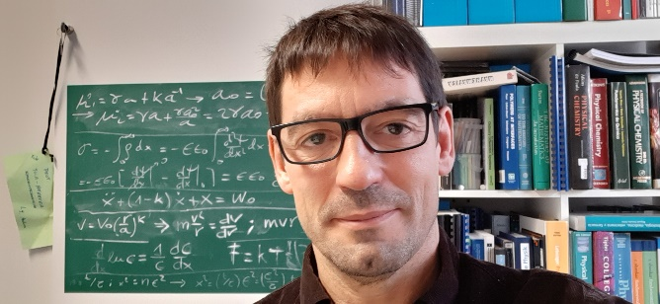

Prof. Dr. Jose L. Toca-Herrera, Head of the Institute of Biophysics at BOKU, Vienna, Austria.

José L. Toca-Herrera graduated in Physics at the University of Valencia. He completed a one-year research internship at the Max-Planck Institute for Polymer Research (Prof. W. Knoll) and completed his PhD at the Max-Planck Institute for Colloids and Interfaces under the supervision of Prof. Helmuth Möhwald. After postdoctoral stays at the Technical University of Berlin (Prof. R. v. Klitzing), the University of Cambridge (Prof. J. Clarke), and BOKU-Vienna (Prof. U. B. Sleytr), he started at the University Rovira i Virgili as RyC Research Professor (Tarragona, Spain), and later moved to CIC-BiomaGUNE (San Sebastian, Spain). In 2010, he joined BOKU-Vienna as Full Professor (Chair), where he heads the Institute of Biophysics. In addition, Prof. Toca-Herrera is deputy head of the Department of Bionanosciences.
His research interests include soft matter, colloids, interfaces, and mathematical methods although his main passion is teaching.
To date he has published more than 140 scientific papers, 3 books and supervised more than 40 theses (PhD, MSc and BSc). He is proud of the success of his students in academia and industry. José has been visiting professor at the Max-Planck Institute of Colloids and Interfaces (Golm) and at the Faculty of Physics and Applied Computer Science of the AGH-University (Krakow). He has also been evaluator for more fourteen national e international agencies (e.g., European Research Council (ERC), Czech Science Foundation, Deutsche Forschungsgemeinschaft, Swiss Science Foundation).

The Institute of Biophysics (as part of the Department of Bionanosciences) aims to understand the physical behavior of biological materials from the nanometer to the micrometer scale (e.g., human and plant cells, and its relation to function). Briefly, the research topics of the institute can be summarized as i) Self-assembly processes involving crystal, lipid membrane formation, and biomimetic interfaces; ii) Mechanical and structural properties of biological materials (e.g., proteins, bacteria, human and plant cells); iii) Controlling molecular and surface interactions through surface chemistry modification methods; iv) Implementation and application of physical and mathematical methods (AFM, Raman and IR spectroscopy, algorithm development) to biological materials, interfaces, and environmental and sports sciences. The research and academic activities of the institute for Biophysics profit from the mixture of the different scientific backgrounds of its members (biology and biotechnology, chemistry, and physics). Every year, the institute receives visiting scholars and professors that spent between 3- and 6-months doing research activities. The Institute of Biophysics has access to the following laboratory facilities: JPK Nanowizard3 atomic force microscopy coupled to a Zeiss fluorescence microscope, high resolution atomic force microscope (Nanoscope V Multimode), JPK Nanowizard I atomic force microscope, scanning electron microscopy and transmission electron microscopy, confocal laser scanning microscopy (Model Zeiss LSM510 Meta), quartz microbalance with dissipation (E4 QSense), high-vacuum sputtering, contact angle, light scattering, flow cytometer, Raman and infrared spectrometer, and UV/Vis spectrometer.
A full description (annual report) of the academic and scientific activities of the hosting institute can be download from https://www.nano.boku.ac.at/biophysics/annual-report/

BOKU
The University of Natural Resources and Life Sciences Vienna (BOKU) was founded in 1872. BOKU is based on three pillars: natural sciences, technology, and social sciences. Thus, BOKU research is highly multidisciplinary. It focuses on i) the conservation and development of protection for habitats, ii) economy and living standards, iii)
the management of natural resources and environment, iv) the protection of food and health.
BOKU as green university has the goal of integrating sustainability into all processes in society. It is a member of the Euroleague for Life Sciences (ELLS), the United Nations Academic Impact (UNAI), the European University Initiative (EPICUR), and the Austrian-African Research Network (Africa UniNet). In numbers, there are currently 10,941 students from over 100 countries enrolled at BOKU. BOKU has about 2000 academic staff, 800 administrative staff and 11000 students.

