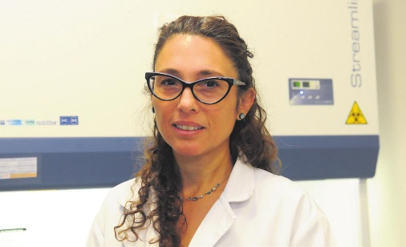
Dra. Laura Alaniz (CARES associated, Argentina), lead of Tumor Microenvironment Laboratory at Center for Basic and Applied Research (CIBA), National University of the Northwest of the Province of Buenos Aires. (UNNOBA, Junín, Bs. As. Arg.). Independent researcher from CONICET. CEO and Co-founder MesencHyal-T S.A.

Laura Alaniz is biochemist, graduated from the School of Pharmacy and Biochemistry (FFyB), University of Buenos Aires (UBA, Argentina). She developed her PhD career at the University of Buenos Aires (UBA) at Institute for the Study of Humoral Immunity Prof. R.A. Margni (FFyB, UBA). She commenced her career as an assistant researcher in CONICET at the Faculty of Biomedical Sciences, Austral University. Laura started her own lab at CIT NOBA (CONICET-UNSADA-UNNOBA), with workplace CIBA. Her scientific career is focused on the area of medical sciences, specifically in the molecular study of the extracellular component: Hyaluronic Acid. Besides, she currently is CEO and Co-Founder of MesencHyal-T SA, a Start-up for bone regenerative medicine.
The Tumor Microenvironment Lab is studying the interaction between components of the extracellular matrix (ECM), immune system (macrophages, DC) and other stromal cells in a tumor context. The lab is focused on glycosaminoglycan (GAG), hyaluronic acid (HA) and their chemically modified derivatives as modulators of tumors of different etiology (breast, colorectal, gynecological cancer). The lab objective is found molecular biomarkers for detected drug resistance and biomarkers of cancer progression associated to hyaluronic metabolism. The lines of research that are currently being developed with central axis of the HA molecule, include the study of:
-Epigenetic modulation of DNA repair genes by HA metabolism. Therapeutic impact in breast and colon cancer
-Study of the resistance to drugs dependent on GAG of the ECM in different types of tumors. Perspectives for the repositioning of oncology drugs
-Modulation of mesenchymal stem cell behavior by sulfated hyaluronic acid in a model of bone lesion.
-Implications of sulfated hyaluronic acid in the antitumor immune response and angiogenic modulation.
CIBA, is a center dedicated to biology and biochemistry research located in a specific building. It has a research area occupying 430m2, two floors. Four lab rooms, large equipment, real-timePCR, molecular biology, immunoassay, histochemistry, etc. A Cytometer room BDFACS Canto II flowcytometer, BDFACS Melody™CellSorter, for multiple analysis of phenotypes and separation of cells. Confocal and Fluorescence microscope Axio Imager A2Carl Zeiss. The animal Housing Room has independent units for production facility, experimental facility, quarantine for mice. Area of surgery provided with instrumental and anesthesia machine. IVIS® Spectrum CT preclinical in vivo imaging system.
In the center students are doing their undergraduate degrees in genetics and doctorates, and young researchers are starting their academic and biotechnological scientific careers. It is in a main area of the city, close to different university buildings, such as the library, museum, and dining room, which allows interaction with young students from the region and other careers taught at the university.

