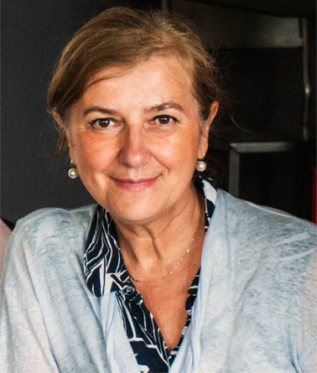

**Dr Patricia Rousselle** is Director of Research at the National Centre for Scientific Research (CNRS) in France. Her laboratory, entitled **«Cell / microenvironment cross talk and tissue repair"**, is part of the Department of Tissue Biology and Therapeutic Engineering at the Institute of Protein Biology and Chemistry (IBCP) in Lyon – one of the most important centres in France specialising in the research fields of extracellular matrix and tissue repair.

Patricia Rousselle obtained her doctorate in pharmacy in 1988 and completed a four-year internship in clinical biology at the University Hospitals of Lyon, where she also obtained an MSc in molecular and cell biology in 1990. She obtained her PhD in 1994 under the supervision of Prof Bob Burgeson at the Shriners Hospital for Crippled Children in Portland, USA, where she discovered the important basement membrane protein laminin 5 (now called laminin 332). She then worked at the Cutaneous Biology Research Centre in Boston, USA, before joining the French CNRS in 1995 to set up her own group. Since then, she has led her research team independently, seeking research funding and building partnerships with industry and scientific collaborations.

Her research focusses on understanding the interactions between cells and extracellular matrix in the context of skin biology. By developing both biochemical and cell biological approaches, her group is interested in analysing molecular and cellular processes during wound healing, with a focus on cell adhesion and migration processes controlled by glycoproteins and proteoglycans of the extracellular matrix. Her recent work has focused on the interactions of basal keratinocytes with extracellular matrix components during the re-epithelialisation phase of wound healing (Re-cover project). In addition, she has long collaborated with hospitals in Lyon, including the Cell and Tissue Bank and the Burns Centre, where she is involved in projects to develop therapies for tissue repair, including extracellular matrix-based scaffolds and mesenchymal stem cells. She was recently awarded the CNRS Innovation Medal 2023.

The Department of Tissue Biology and Therapeutic Engineering is located in the IBCP building on the largest university campus in the Rhône Alpes region in the field of biology, next to the Ecole Normale Supérieure de Lyon, in the heart of the Lyon Gerland biodistrict. It offers the unique opportunity to work with both a large academic environment and private companies. The academic facilities of the campus have been centralised to bring together more than 80 teams and 10 platforms. The campus brings together departments working in different research areas covering the main fields of biology, including infectiology, cell biology, protein biochemistry, bioinformatics, structural biology, genomics and immunology. Resources are pooled in technical platforms giving access to all facilities, from animal hosting to phenotyping and imaging expertise including multiplex cytometry, high-speed sequencing, protein research and Spatial Cell ID. This enables close interaction between researchers from different research areas, including industry partners and clinicians, to develop innovative translational research.

