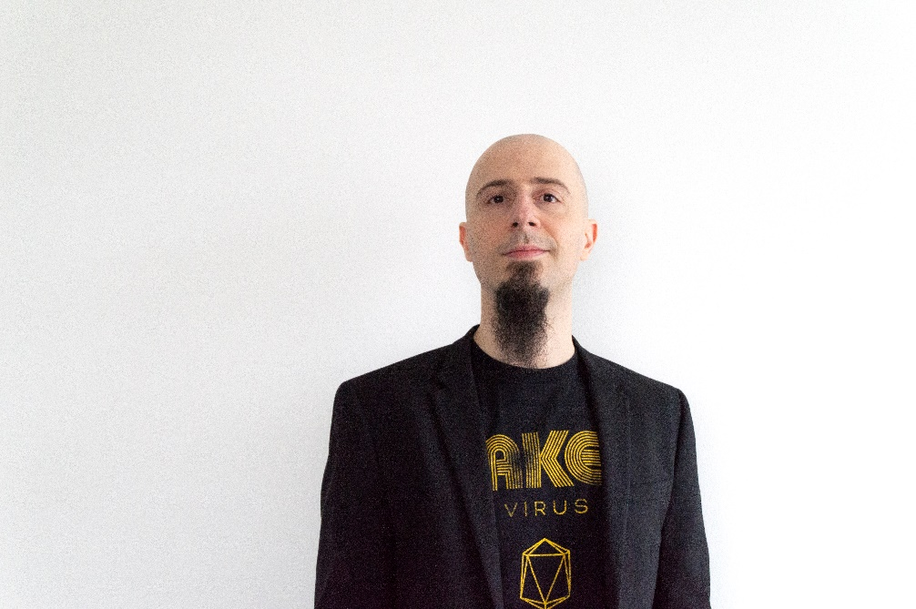

Dr Valerio Izzi, leads the Bioinformatics Group at the University of Oulu, Oulu, Finland.

**Valerio Izzi** graduated from the University of Rome “Tor Vergata” and carried out his PhD thesis jointly at the University of Rome “Tor Vergata” and the Lazzaro Spallanzani IRCSS hospital of Rome. After his post-doctoral studies at the University of Oulu (Finland), where he also got a docentship in Immunology, Valerio was nominated tenure-track associate professor of bioinformatics and started his own lab at the Faculty of Biochemistry and Molecular Medicine (FBMM), where he identified pan-cancer patterns of matrisome gene expression and regulation. The Izzi lab focuses on the development of novel algorithms and web applications for the study of matrisome expression and regulation across multiple data modalities and the democratization of data access. Valerio is also currently chairman of the Finnish Society for Matrix Biology (FSMB) and vice-president of the International Society for Matrix Biology (ISMB).

**The IzziLab** focuses on the development of innovative algorithms for the study of matrisome expression and regulation in multimodal data, simplifying and democratizing data access. Particularly, the IzziLab focuses on the use of network algorithms and machine learning/artificial intelligence for the identification of ECM markers and targets in cancer.